**INTRODUCTION**

A motherboard (sometimes alternatively known as the mainboard, main circuit board, system board, baseboard, planar board or logic board, or colloquially, a mobo) is the main printed circuit board (PCB) found in general purpose computers and other expandable systems. It holds, and allows, communication between many of the crucial electronic components of a system, such as the central processing unit (CPU) and memory, and provides connectors for other peripherals. Unlike a backplane, a motherboard usually contains significant sub-systems such as the central processor, the chipset's input/output and memory controllers, interface connectors, and other components integrated for general purpose use and applications. Motherboard specifically refers to a PCB with expansion capability and as the name suggests, this board is often referred to as the "mother" of all components attached to it, which often include peripherals, interface cards, and daughtercards: sound cards, video cards, network cards, hard drives, or other forms of persistent storage; TV tuner cards, cards providing extra USB or FireWire slots and a variety of other custom components. Similarly, the term mainboard is applied to devices with a single board and no additional expansions or capability, such as controlling boards in laser printers, televisions, washing machines, mobile phones and other embedded systems with limited expansion abilities.

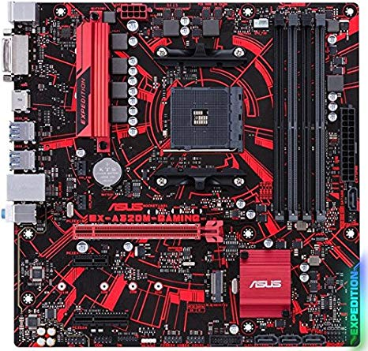

**Types of Motherboard**

**AT Motherboard:**

These Motherboards are the oldest of its kind. AT means the board consists of Advanced Technology (AT) power connectors. The AT Motherboards are used in mid-80’s. The dimensions (13.8 x 12 inch) of this Motherboard make it difficult for new drives to get installed. These Motherboards are used in earlier 286/236 and 436 Computers.

**ATX Motherboard:**

ATX means Advanced Technology extended is the motherboard configuration specification developed in mid-90’s and still available. The ATX Motherboard is an improvement from the previously working Motherboard such as AT. ATX is the most common motherboard design which is used in smaller boards (including micro-ATX, FlexATX, nano-ITX, mini-ITX). Dimensions of a full-size standard ATX board are 12 x 9.6 inch. The ATX Motherboard have gone through lots of upgrades in recent times.

**Micro-ATX Motherboard:**

It is smaller than the typical ATX Motherboards with the dimension of 9.6 x 9.6 inch. Some manufacture has the dimension of 9.6 x 8.1 inch. Most modern ATX motherboards have a maximum of seven PCI or PCI-Express expansion slots, while microATX boards only have a maximum of four.

**Mini ITX Motherboard:**

Mini ITX is 6.7 x 6.7 inch in dimension which is smaller than any other conventional Motherboard. Some of the features and advantages of Mini ITX Motherboard are following bellow.

**E-ATX Motherboard:**

E-ATX is extended ATX Motherboard and its size is huge compared to ATX Motherboard but it doesn’t matter with the size it has many features and uses which other typical motherboard lagging. The E-ATX is mainly used for gaming. This motherboard can be extended to have huge memory and more CPU cores.

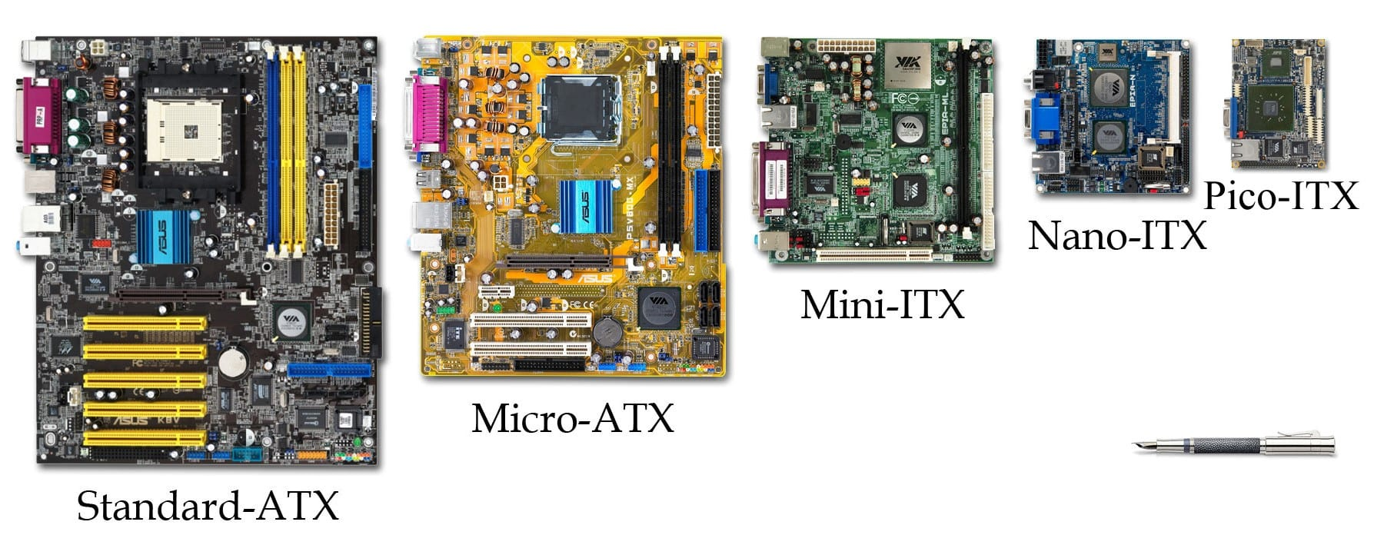

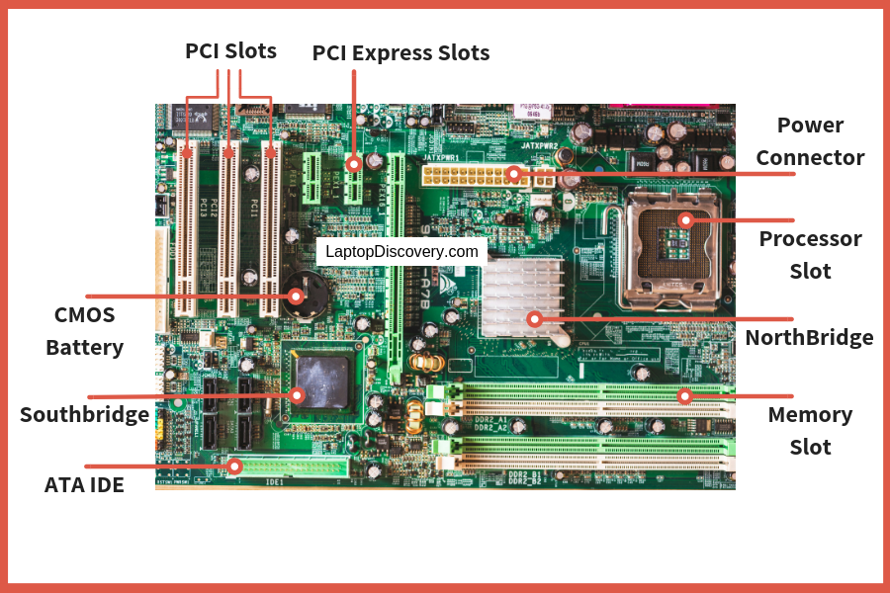

**Components of Motherboard**

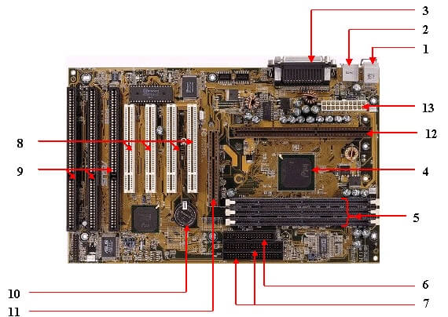

1. Mouse & Keyboard:

There are two types of keyboard and mouse connectors. First type is called PS/2 and second one is called USB.

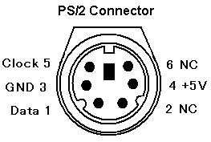

1. USB (Universal serial bus):

USB is Universal serial bus. It is used for connection for PC. There are \ different devices which is used to connect with USB port such as mouse, keyboards, scanners, cameras, and even printers. USB connector is used to connect computer motherboard and a peripheral device. You can insert or remove peripheral device connect by USB connector without restarting your system.

1. Parallel port :

Most of old printers are used to connect by parallel port. Parallel port used more than one wire for sending or receiving multiple bits of data at once, while serial port uses only one wire. Parallel ports use a 25-pin female DB connector.

1. CPU Chip :

CPU refers to a processor, the central processing unit, also called the microprocessor performs all the task that take place inside a computer system.It is also know as brain of computer.

1. RAM slots :

RAM slots is for attaching RAM on it in general desktop we can see two slot of RAM but in server motherboard we can see 4+ slot of RAM.RAM comes in different size(memory).

1. Floppy controller :

In old motherboard the floppy drive connects to the computer via a 34-pin ribbon cable, one end of ribbon cable is connect to floppy drive and other is connected to the motherboard.

1. IDE controller :

IDE that is Integrated Drive Electronics,also called as ATA or Parallel ATA (PATA).IDE controller is responsible for controlling the hard drive. Today’s computers no longer come with a IDE controller.

1. PCI slot :

PCI stands for Peripheral Component Interface, PCI slot allows you to insert expansion cards into your computer. PCI used to connect additional PCI device like network cards, sound cards,modems,video cards.Some of today’s computers no longer come with a PCI expansion slot.Its connect audio, video and graphics.

1. ISA slot :

ISA stands for Industry Standard Architecture, It is the standard architecture of the Expansion bus.Its connect modem and input devices.

1. CMOS Battery :

CMOS is complementary metal-oxide-semiconductor is used to store BIOS setting in computer motherboard. CMOS Battery also store date and time.

1. AGP slot :

The Accelerated Graphics Port (AGP) is a high-speed point-to-point channel for attaching a video card to a computer system, If you have a modern motherboard, you will almost certainly notice a single connector that looks like a PCI slot.A fast port for a graphics card.

1. CPU slot :

The processor socket (also called a CPU socket) is the connector on the motherboard that connect a CPU.

1. Power supply plug in :

The Power supply provides the necessary electrical power to make the computer system operate. The power supply takes standard 110-V AC power and converts into +/-12-Volt, +/-5-Volt, and 3.3-Volt DC power.

The power supply connector has 20-pins, and the connector can go in only one direction.

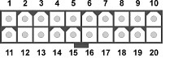

**Connector Side of Motherboard**

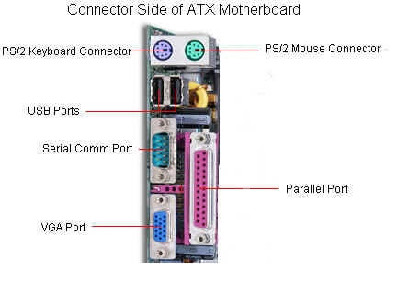

1. Keyboard & Mouse: This Port is used to connect keyboard and mouse, now a day we use USB connector for keyboard and mouse.

component of motherboard Keyboard port

2. Serial or COM: It used to connect some types of modem, scanner, or digital camera.

component of motherboard serial port

3. Parallel or Printer: You plug your printer into the parallel, or printer, port. But now printers may use a USB port

component of motherboard parallel Port

4. USB : Universal Serial Bus can connect computers with a number of devices, such as printers, keyboards, and more

component of motherboard USB port

5. Video or Monitor : It used to connect your monitor into the video port

component of motherboard monitor Port

6. Line Out : It used to connect speakers or headphone into the Line Out jack



7. Line In : The Line In jack allows you to listen to your computer using a stereo system



8. Microphone : It used to connect a microphone into this jack to record sounds on your computer

component of motherboard microphone port

9. Joystick or Game : If you have a joystick, musical (MIDI) keyboard, or other gaming device, this is where you plug it in



10. Phone or Modem : The phone or modem jack is where you plug your computer into a phone line

component of motherboard Phone or Modem port

11. Network or Ethernet : You can connect your computer to a network.

component of motherboard LAN port

12. SCSI : It used to connect a hard drive, CD-ROM drive, or other device to a computer



Active and Passive Components

Active Component:

An active component is a device that has an analog electronic filter with the ability to amplify a signal or produce a power gain. There are two types of active components: electron tubes and semiconductors or solid-state devices. A typical active component would be an oscillator, transistor or integrated circuit.Active components include amplifying components such as transistors, triode vacuum tubes (valves), and tunnel diodes.

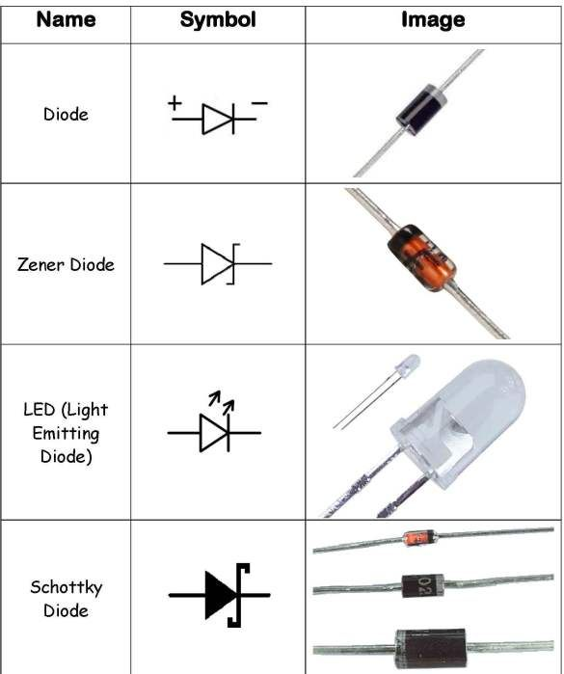

Passive Components:

Passive components include two-terminal components such as resistors, capacitors, inductors, and transformers. Electromechanical components can carry out electrical operations by using moving parts or by using electrical connections.

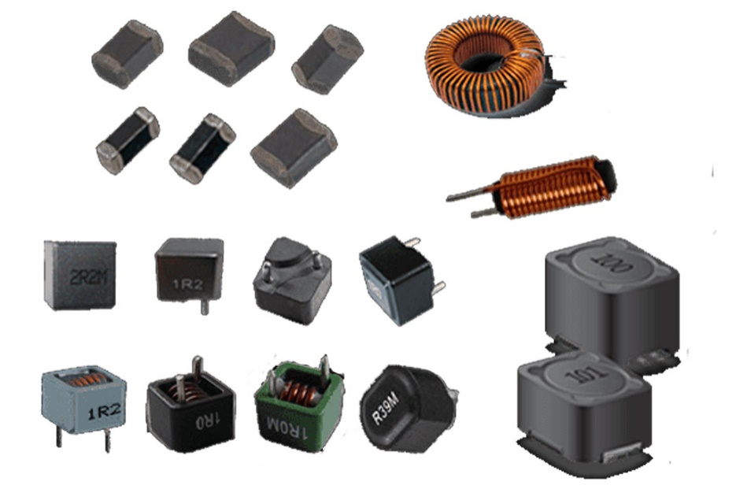

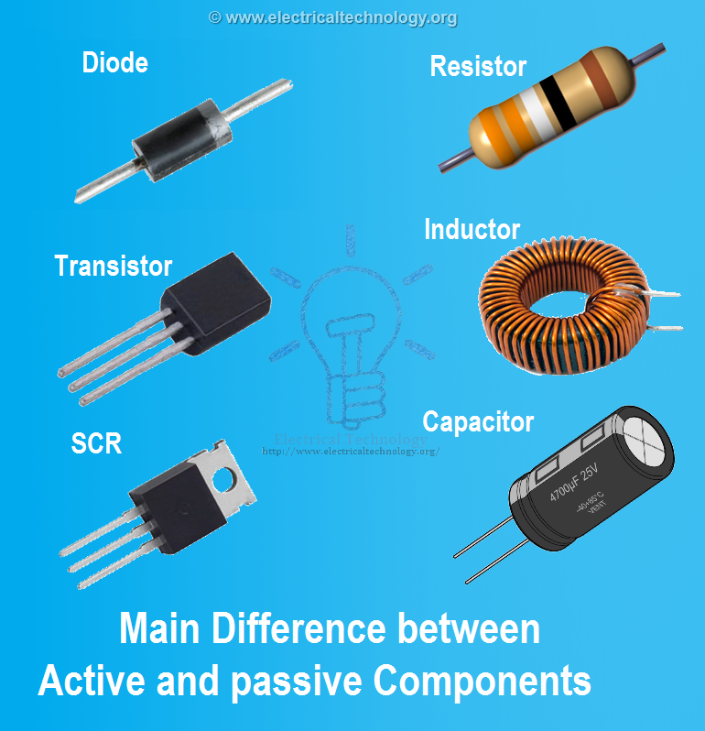

**Main Difference between Active and Passive Components**

Left Side:

Active Component

Right Side:

Passive Component

**Top Motherboard Manufacturer’s**

Below are the top motherboard manufactures:

1. ASUS

AsusTek Computer Inc. is a Taiwan-based multinational computer and phone hardware and electronics company headquartered in Beitou District, Taipei, Taiwan. Its products include desktops, laptops, netbooks, mobile phones, networking equipment, monitors, WIFI routers, projectors, motherboards, graphics cards, optical storage, multimedia products, peripherals, wearables, servers, workstations, and tablet PCs. The company is also an original equipment manufacturer (OEM).Asus is the world's 5th-largest PC vendor by 2017 unit sales. Asus appears in BusinessWeek's "InfoTech 100" and "Asia's Top 10 IT Companies" rankings, and it ranked first in the IT Hardware category of the 2008 Taiwan Top 10 Global Brands survey with a total brand value of $1.3 billion.Asus has a primary listing on the Taiwan Stock Exchange under the ticker code 2357 and a secondary listing on the London Stock Exchange under a ticker code ASKD.

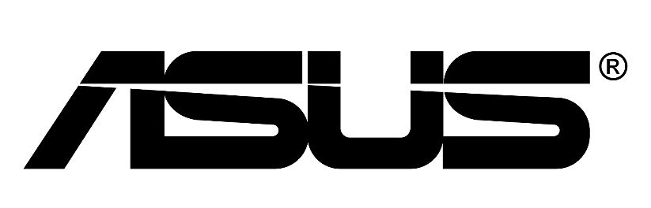

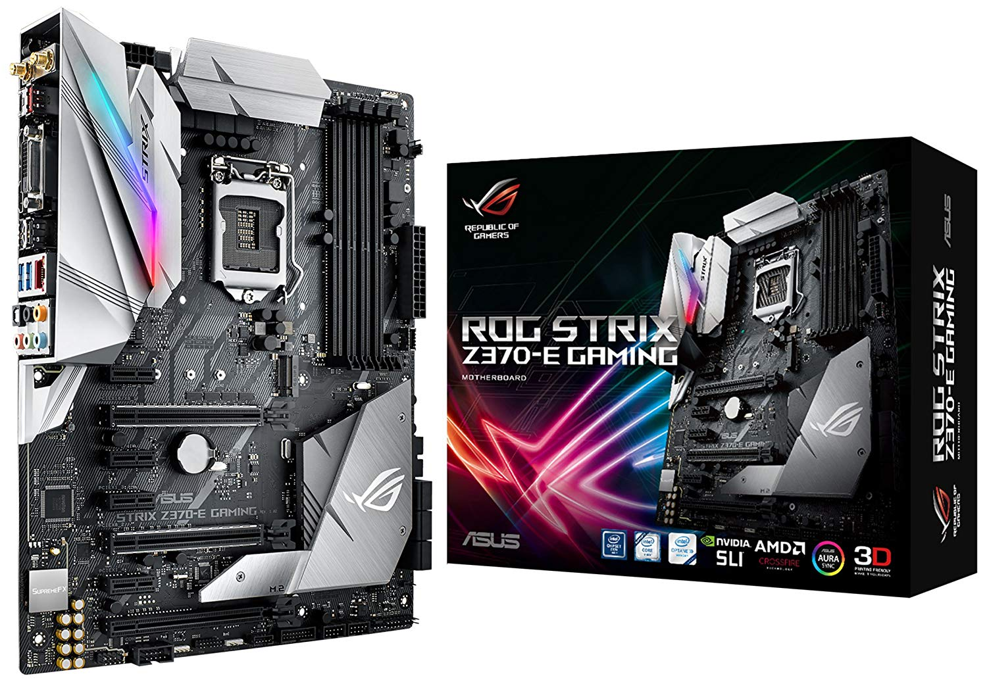

2. Gigabyte Technology

Gigabyte Technology is a Taiwanese manufacturer and distributor of computer hardware.Gigabyte's principal business is motherboards, with shipments of 4.8 million motherboards in Q1 2015, while Asus shipped around 4.5 million motherboards in the same quarter. Gigabyte also manufactures custom graphics cards and laptop computers (including thin and light laptops under its "Aero" sub-brand). In 2010, Gigabyte was ranked 17th in "Taiwan's Top 20 Global Brands" by the Taiwan External Trade Development Council.The company is publicly held and traded on the Taiwan Stock Exchange, stock ID number TWSE: 2376.

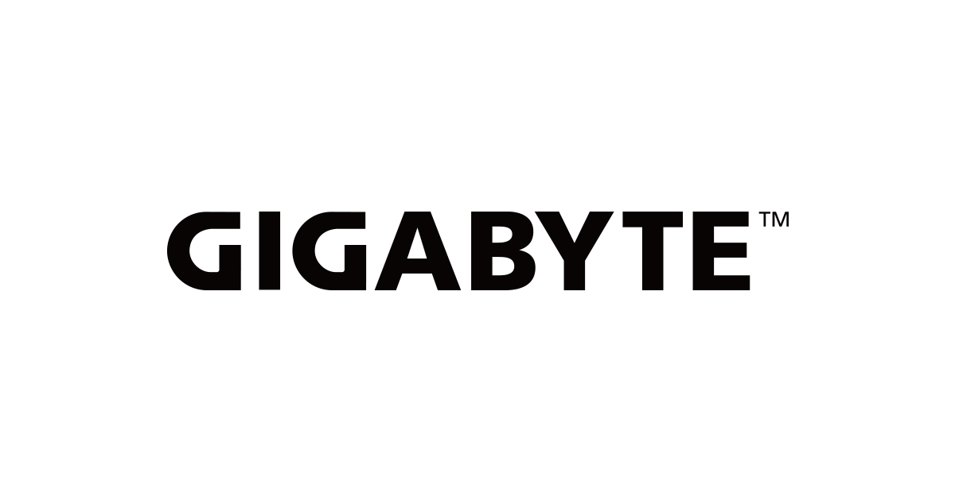

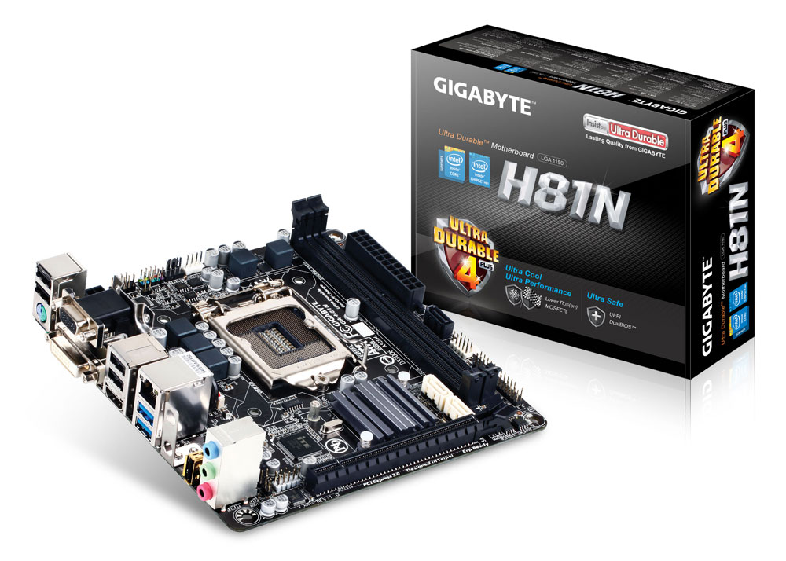

3. Micro-Star International

Micro-Star International Co., Ltd (MSI) is a Taiwanese multinational information technology corporation headquartered in New Taipei City, Taiwan. It designs, develops and provides computer hardware, related products and services, including laptops, desktops, motherboards, graphics cards, All-in-One PCs, servers, industrial computers, PC peripherals, car infotainment products, etc. The company has a primary listing on the Taiwan Stock Exchange and was established in August 1986 by 5 founders – Hsu Xiang (a.k.a. Joseph Hsu), Huang Jinqing (a.k.a. Jeans Huang), Lin Wentong (a.k.a. Frank Lin), Yu Xian'neng (a.k.a. Kenny Yu), and Lu Qilong (a.k.a. Henry Lu). First starting its business in New Taipei City, Taiwan, MSI later expanded into Mainland China, setting up its Baoan Plant in Shenzhen in 2000 and establishing research and development facilities in Kunshan in 2001. It also provides global warranty service in North America, Central/South America, Asia, Australia and Europe.The company has been a sponsor for a number of esports teams and is also the host of the international gaming event MSI Masters Gaming Arena (formerly known as MSI Beat IT). The earliest Beat IT tournament can be traced back to 2010, featuring Evil Geniuses winning the championship. The company's slogan as seen in 2017 is "TRUE GAMING. SOME ARE PC, WE ARE GAMING."

